**Bahria University, Lahore Campus**

Department of Computer Science

Lab Journal 03

**(Spring 2024)**

|  |  |  |
| --- | --- | --- |
| Course: | **Compiler Construction – Lab** | Date: _8-3-2024__ |
| Course Code: | CSL 323 | Max Marks: 10 |
| Faculty’s Name: | Mr. M Mudassar |  |

Name: AFFAN AHMAD_ Enroll No: _03-134221-003_ Class: BS(CS5-A)

Objective(s):

Upon completion of this lab session, learners will be able to:

* The objective of this exercise is to get you to write, compile, and run several simple programs in C++ that help to recognize tokens (words) by getting input from the user and from the text file.

Lab Tasks:

Your lab report is expected to contain the following for each exercise:

* C++ Source Code (any file)
* Screenshot of your output (optional)

## Task 1:

Write a program that read input text (or program) from the text file and recognizes tokens (words) from it. Tha data of text file must be loaded into two fixed size buffer arrays (optionally can be of size 100). First, the data must be loaded into buffer-1, then into buffer-2, and if still there is data to read, again it loads in the buffer-1 and then buffer-2. The process must repeat until the data or content ends in the text file. You are not allowed to use of separate word array. The program must display each token (word) in a single line.

**PROGRAM:**

#include <iostream>

#include <sstream>

#include <string>

using namespace std;

const int BUFFER_SIZE = 100;

void processBuffer(const string& buffer) {

istringstream iss(buffer);

string token;

while (iss >> token) {

cout << token << endl;

}

}

int main() {

char buffer1[BUFFER_SIZE];

char buffer2[BUFFER_SIZE];

bool useBuffer1 = true;

cout << "Enter text (press Ctrl+D on a new line to end input):\n";

while (cin.good()) {

char* currentBuffer = (useBuffer1) ? buffer1 : buffer2;

cin.getline(currentBuffer, BUFFER_SIZE);

processBuffer(currentBuffer);

useBuffer1 = !useBuffer1;

}

return 0;

}

**OUTPUT:**

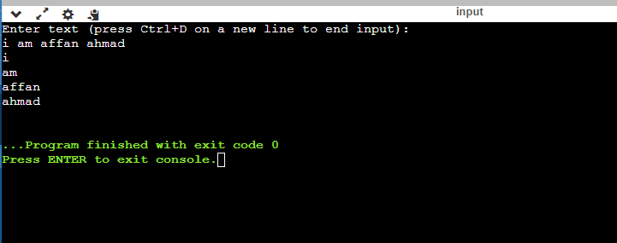

**Lab Grading Sheet :**

|  |  |  |  |
| --- | --- | --- | --- |
| **Task** | **Max Marks** | **Obtained Marks** | **Comments(*if any*)** |
| 1. | 05 |  |  |
| 2. | 05 |  |  |
|  |  |  |  |
|  |  |  |  |
| **Total** | **10** |  | **Signature** |

**Note: Attempt all tasks and get them checked by your Lab Instructor.**